|  |
| --- |
| **rmp software solutions** |
| **SLOT MACHINE** |
| *Assignment 02* |
| Version 1  All work Copyright © 2015 by XX Games.  All rights reserved. |
| **RUKSHAR PATEL** |
|  |

|  |
| --- |
| June 22th 2015 |

Table of Contents

Version History 3

Game Overview 4

Game Play Mechanics 4

Controls 4

Interface Sketch 4

Menu and Screen Description 5

Game Progression 5

Items 5

Scoring 6

Bonuses 6

Design Notes 6

Note 6

# Version History

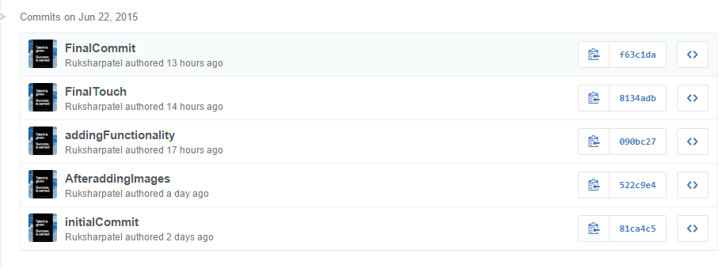

***Link to GitHub***: https://github.com/Ruksharpatel/Assignment02

### Game Overview

Slot Machine is a game where player plays his bet and tries his luck. It is also known as poke machine or fruit machine. The machine pays off based on patterns of symbols visible on the front of the machine when it stops. Slot machines are the most popular gambling methods in the casinos. A person playing a slot-machine can insert cash, or in Ticket-In, Ticket-Out, a paper with barcode, into a designated slot on the machine. Objective of the game is to win the money from the machine. The winning part is determined when the machine gives matching symbols in the reels when the spin button is pressed or clicked. In this web-based game, the player can start with 1000 dollars which they can use to bet and play slots.

### Game Play Mechanics

This game provides several game elements as button which player interacts with on the screen. In addition to the specific slot-machine buttons, an additional button is provided if the user wants to exit the game or close the current window.

### Controls

This game only uses the buttons as controls which player will use while interacting with UI. Five buttons are provided namely SPIN, BET ONE (to bet the lowest amount i.e. $10), BET MAX (to bet the highest possible amount i.e. $1000), RESET (to reset the bet amount to their default), two buttons to increase or decrease the bet amount and the power button if user wants to quit the game.

### Interface Sketch

The UI of this game is pretty simple so that the focus of the player remains on the game. Only the background has been added to give the look and feel of the slot machine.

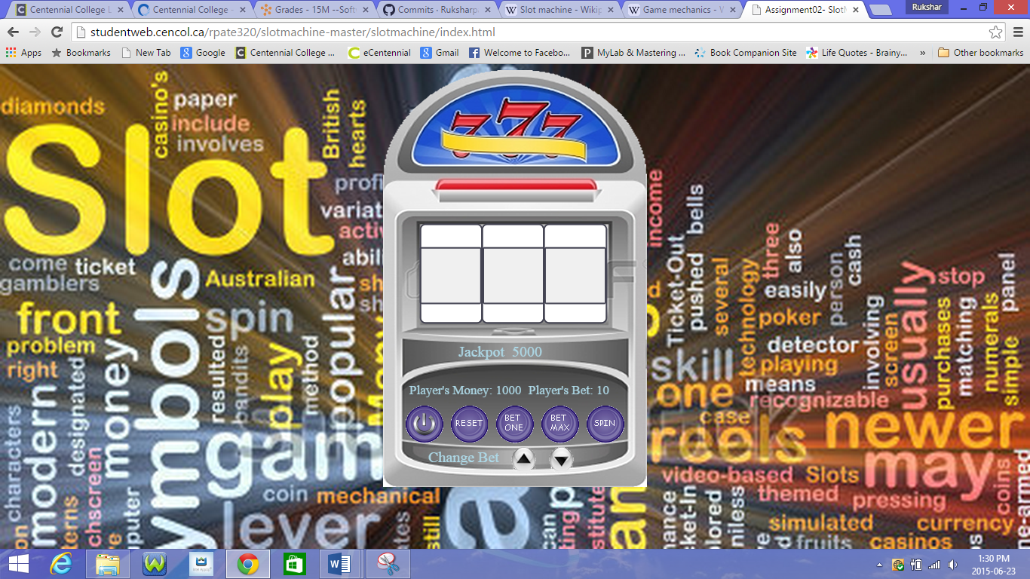

### Menu and Screen Description

The slot machine is placed in the center of the screen. The labels for player’s money and their Bet is placed above the buttons side by side. Also, the buttons are placed next to each other to avoid complexity. For the player to change Bet amount two buttons are provided at the end of the slot machine where player can increase or decrease their amount. Also, the buttons has their appropriate functionality and validations respective to the game. The UI is created keeping in mind readability, portability and easy to use.

### Game Progression

The progress of this game takes place when the player places some bet and wins or they win the jackpot. If the player doesn’t have enough money to play the bet, alert box appears that they cannot play more and has to restart the game.

### Items

This Game uses eight different symbols as Items. These symbols appears inside the reels when the player clicks the spins button. The random occurrences of symbols decides the player winnings.

### Scoring

The score of the player determines the amount of cash the player has earned. When the spin button is pressed it gives random symbols on the screens which decides the player’s cash. Every time the player wins the cash increases. The chances of winning is rare in this game.

### Bonuses

The player has a winning jackpot as bonus. Winning of the jackpot is determined by comparing two random occurrences of the symbols.

### Design Notes

The design of this game is simple, user friendly, reliable and portable.

### Note

### **The power button works with Internet Explorer not with the Google Chrome.**